**Die Alltagshilfe**

public class JugendForscht2018 {

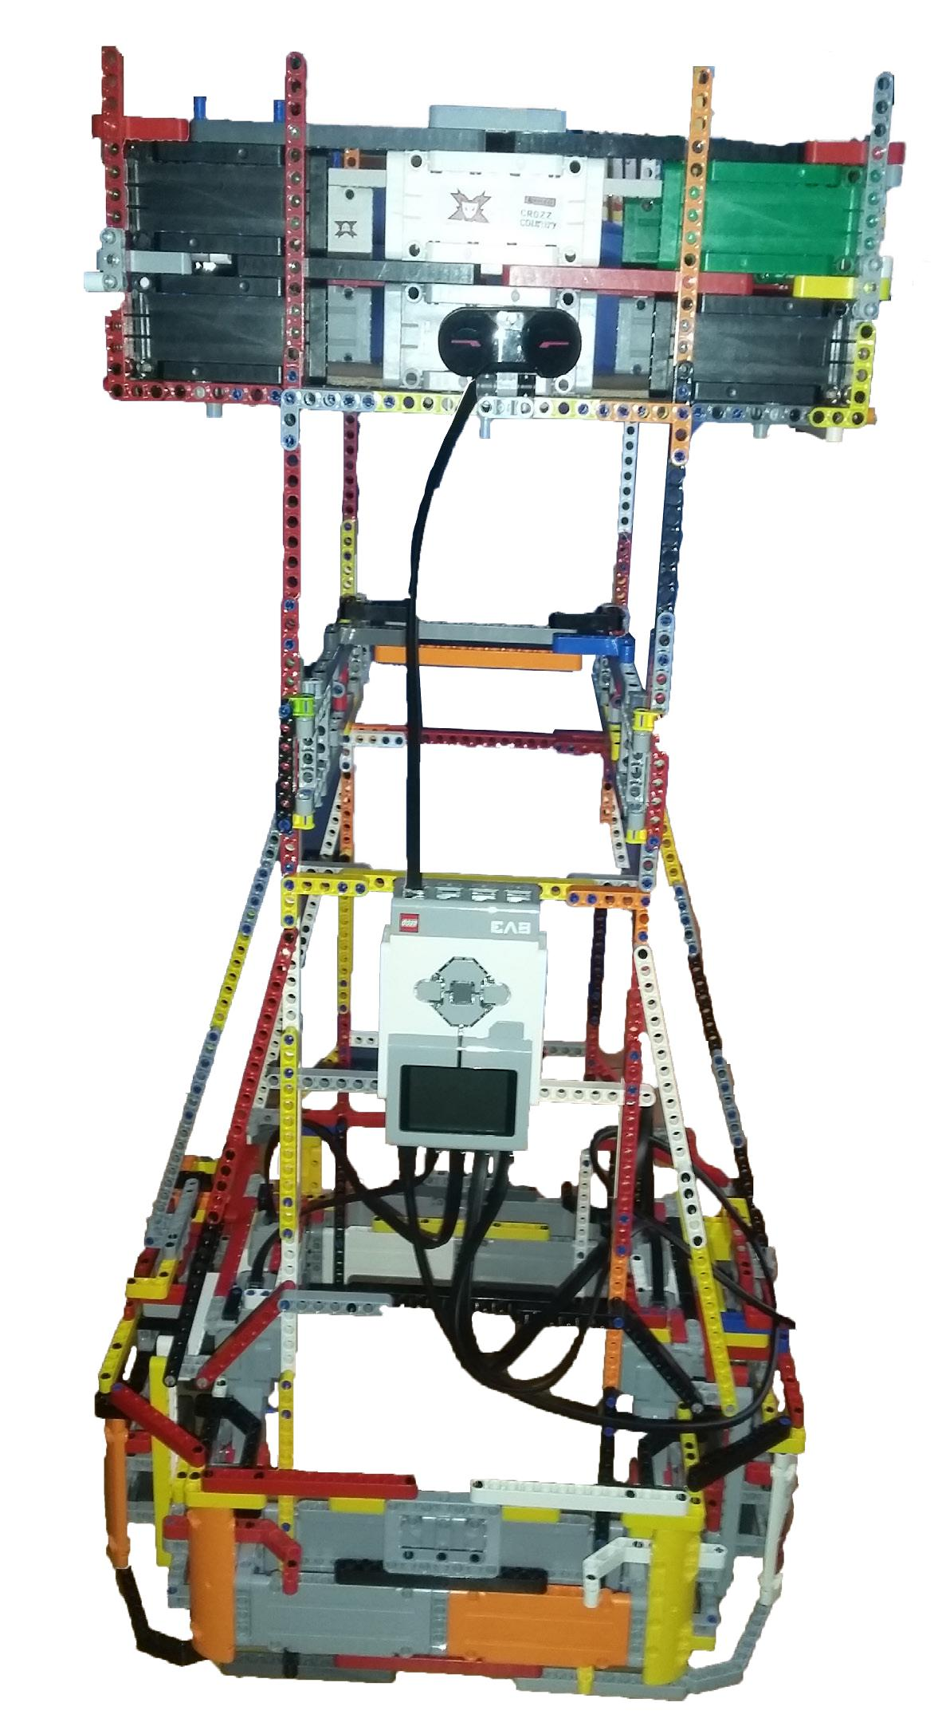

public JugendForscht2018() {

int currentTime;

int startTime = 2015;

int pDuration = 3; //3 Jahre

int endTime = startTime + pDuration;

boolean working = false;

User user1 = new Nerd();

User user2 = new Nerd(); user1.setName(„Vincent“); user2.setName(„Fabian“); user1.setSchool(„SGG Bingen“); user2.setSchool(„SGG Bingen“);

Team Juforge = new Team(user1, user2);

Project project = new Project();

project.setName(„Die Alltagshilfe“); project.setMaterial(Material.Lego); project.setLanguage(Language.Java); project.setDuration(pDuration); JuForge.setProject(project);

working = true;

while(working)

currentTime = System.getYear();

if(currentTime < endTime) {

user1.think();

user2.think();

user1.code();

user2.build();

} else { JuForge.goToCompetition();

}

}

if(project.isBest) {

JuForge.isWinner = true;

}

Ein Projekt von Vincent Schmandt und Fabian Specht

vom Stefan - George – Gymnasium